QMM ASSIGNMENT 4

Akanksha Nadukula

2022-10-30

knitr::opts_chunk$set(message = FALSE)  
knitr::opts_chunk$set(warning = FALSE)

library("Benchmarking")

data.df.values <- matrix(c("Facility 1","Facility 2","Facility 3","Facility 4","Facility 5", "Facility 6",  
 150,400,320,520,350,320,  
 0.2,0.7,1.2,2.0,1.2,0.7,  
 14000,14000,42000,28000,19000,14000,  
 3500,21000,10500,42000,25000,15000), ncol=5, byrow=F)  
  
colnames(data.df.values) <- c("DMU", "Staff_Hours_Per_Day","Supplies_Per_Day","Reimbursed_Patient_Days","Privately_Paid_Patient_Days")  
  
table.df <- as.table(data.df.values)  
table.df

## DMU Staff_Hours_Per_Day Supplies_Per_Day Reimbursed_Patient_Days  
## A Facility 1 150 0.2 14000   
## B Facility 2 400 0.7 14000   
## C Facility 3 320 1.2 42000   
## D Facility 4 520 2 28000   
## E Facility 5 350 1.2 19000   
## F Facility 6 320 0.7 14000   
## Privately_Paid_Patient_Days  
## A 3500   
## B 21000   
## C 10500   
## D 42000   
## E 25000   
## F 15000

Here we are calculating Constant that Returns to Scale (CRS)

x <- matrix(c(150,400,320,520,350,320,  
 0.2,0.7,1.2,2.0,1.2,0.7),ncol=2)  
  
y <- matrix(c(14000,14000,42000,28000,19000,14000,  
 3500,21000,10500,42000,25000,15000),ncol=2)  
  
colnames(y) <- c("Reimbursed_Patient_Days","Privately_Paid_Patient_Days")  
  
colnames(x) <- c("Staff_Hours_Per_Day","Supplies_Per_Day")  
  
D_E_A_crs<-dea(x, y, RTS = "crs")  
D_E_A_crs

## [1] 1.0000 1.0000 1.0000 1.0000 0.9775 0.8675

peers(D_E_A_crs)

## peer1 peer2 peer3  
## [1,] 1 NA NA  
## [2,] 2 NA NA  
## [3,] 3 NA NA  
## [4,] 4 NA NA  
## [5,] 1 2 4  
## [6,] 1 2 4

lambda(D_E_A_crs)

## L1 L2 L3 L4  
## [1,] 1.0000000 0.00000000 0 0.0000000  
## [2,] 0.0000000 1.00000000 0 0.0000000  
## [3,] 0.0000000 0.00000000 1 0.0000000  
## [4,] 0.0000000 0.00000000 0 1.0000000  
## [5,] 0.2000000 0.08048142 0 0.5383307  
## [6,] 0.3428571 0.39499264 0 0.1310751

**CRS Observations:-*

a.We can observe the effectiveness of Facilities 1, 2, 3, and 4.*

1. Additionally, we observe that the ineffective facilities Facility 5 and Facility 6 have Facility 1, Facility 2, and Facility 4 as peer members.*
2. Facility 5 has an efficiency rate of 97.75%, leaving 2.25% inefficient. *d.And Facility 6 has an efficiency rate of 86.75%, leaving a 13.25% inefficiency.*

**Calculating the Decreasing that returns to Scale (DRS)*

D_E_A_drs <- dea(x, y, RTS = "drs")  
D_E_A_drs

## [1] 1.0000 1.0000 1.0000 1.0000 0.9775 0.8675

peers(D_E_A_drs)

## peer1 peer2 peer3  
## [1,] 1 NA NA  
## [2,] 2 NA NA  
## [3,] 3 NA NA  
## [4,] 4 NA NA  
## [5,] 1 2 4  
## [6,] 1 2 4

lambda(D_E_A_drs)

## L1 L2 L3 L4  
## [1,] 1.0000000 0.00000000 0 0.0000000  
## [2,] 0.0000000 1.00000000 0 0.0000000  
## [3,] 0.0000000 0.00000000 1 0.0000000  
## [4,] 0.0000000 0.00000000 0 1.0000000  
## [5,] 0.2000000 0.08048142 0 0.5383307  
## [6,] 0.3428571 0.39499264 0 0.1310751

**DRS Observations**

1. We are able to observe the effectiveness of Facilities 1, 2, 3, and 4.*
2. Additionally, we observe that the ineffective facilities Facility 5 and Facility 6 have Facility 1 and Facility 2 as peer members.*
3. Facility 6 is 86.75 percent efficient, leaving 13.25 percent inefficient, while Facility 5 is 97.75 percent efficient, leaving 2.25% as inefficient.*

***Calculating Increasing Returns to Scale (IRS)***

D_E_A_irs <- dea(x, y, RTS = "irs")  
D_E_A_irs

## [1] 1.0000 1.0000 1.0000 1.0000 1.0000 0.8963

peers(D_E_A_irs)

## peer1 peer2 peer3  
## [1,] 1 NA NA  
## [2,] 2 NA NA  
## [3,] 3 NA NA  
## [4,] 4 NA NA  
## [5,] 5 NA NA  
## [6,] 1 2 5

lambda(D_E_A_irs)

## L1 L2 L3 L4 L5  
## [1,] 1.0000000 0.0000000 0 0 0.0000000  
## [2,] 0.0000000 1.0000000 0 0 0.0000000  
## [3,] 0.0000000 0.0000000 1 0 0.0000000  
## [4,] 0.0000000 0.0000000 0 1 0.0000000  
## [5,] 0.0000000 0.0000000 0 0 1.0000000  
## [6,] 0.4014399 0.3422606 0 0 0.2562995

*IRS Observations**

1. Our ability to observe the effectiveness of Facilities 1, 2, 3, 4, and 5 is demonstrated.*
2. Additionally, we learn that the ineffective Facility 6 has as peer members Facility 1, Facility 2, and Facility 5.*
3. Facility 6 has an efficiency rate of 89.63%, leaving 10.37% inefficient.*

***Calculating Variable Returns to Scale (VRS)***

D_E_A_vrs <- dea(x, y, RTS = "vrs")  
D_E_A_vrs

## [1] 1.0000 1.0000 1.0000 1.0000 1.0000 0.8963

peers(D_E_A_vrs)

## peer1 peer2 peer3  
## [1,] 1 NA NA  
## [2,] 2 NA NA  
## [3,] 3 NA NA  
## [4,] 4 NA NA  
## [5,] 5 NA NA  
## [6,] 1 2 5

lambda(D_E_A_vrs)

## L1 L2 L3 L4 L5  
## [1,] 1.0000000 0.0000000 0 0 0.0000000  
## [2,] 0.0000000 1.0000000 0 0 0.0000000  
## [3,] 0.0000000 0.0000000 1 0 0.0000000  
## [4,] 0.0000000 0.0000000 0 1 0.0000000  
## [5,] 0.0000000 0.0000000 0 0 1.0000000  
## [6,] 0.4014399 0.3422606 0 0 0.2562995

*VRS Observations*

1. We learn how effective Facilities 1, 2, 3, 4, and 5 are.
2. Additionally, we learn that Facility 6—the only inefficient facility—has as peer members Facility 1, Facility 2, and Facility 5.
3. Facility 6 has an efficiency rate of 89.63%, leaving a 10.37% inefficiency.

***Calculating the Free Disposability Hull (FDH)***

D_E_A_fdh <- dea(x, y, RTS = "fdh")  
D_E_A_fdh

## [1] 1 1 1 1 1 1

peers(D_E_A_fdh)

## peer1  
## [1,] 1  
## [2,] 2  
## [3,] 3  
## [4,] 4  
## [5,] 5  
## [6,] 6

lambda(D_E_A_fdh)

## L1 L2 L3 L4 L5 L6  
## [1,] 1 0 0 0 0 0  
## [2,] 0 1 0 0 0 0  
## [3,] 0 0 1 0 0 0  
## [4,] 0 0 0 1 0 0  
## [5,] 0 0 0 0 1 0  
## [6,] 0 0 0 0 0 1

*FDH Observations*

The DMUs are all effective. Due to the principle that the FDH technique uses, it can typically identify even a very low degree of efficiency.

***Calculating Free Replicability Hull (FRH)***

#Here FRH is calculated by specifying RTS = "add"  
D_E_A_frh <- dea(x, y, RTS = "add")  
D_E_A_frh

## [1] 1 1 1 1 1 1

peers(D_E_A_frh)

## peer1  
## [1,] 1  
## [2,] 2  
## [3,] 3  
## [4,] 4  
## [5,] 5  
## [6,] 6

lambda(D_E_A_frh)

## L1 L2 L3 L4 L5 L6  
## [1,] 1 0 0 0 0 0  
## [2,] 0 1 0 0 0 0  
## [3,] 0 0 1 0 0 0  
## [4,] 0 0 0 1 0 0  
## [5,] 0 0 0 0 1 0  
## [6,] 0 0 0 0 0 1

*FRH Observations*

The DMUs are all effective. It ensures that the o/p is free from disposal and replication because it adheres to the no convexity assumption.

***Summary of Results (Inefficient DMUs)***

data.df.summarise.inefficient <- matrix(c("CRS","DRS","IRS","VRS","FDH","FRH",  
2,2,1,1,0,0,  
"Facility 5 & 6", "Facility 5 & 6","Facility 6", "Facility 6", "-","-",  
"97.75% & 86.7%","97.75% & 86.7%","89.63%","89.63%","-","-",  
"Facility 1, 2 & 4","Facility 1, 2 & 4","Facility 1, 2 & 5","Facility 1, 2 & 5","-","-",  
"0.2, 0.08, 0.54 and 0.34, 0.4, 0.13", "0.2, 0.08, 0.54 and 0.34, 0.4, 0.13", "0.4, 0.34 and 0.26", "0.4, 0.34 and 0.26", "-","-"),ncol=6,byrow=F)  
  
  
colnames(data.df.summarise.inefficient) <- c("RTS","Count_Inefficient_DMUs","Name_DMUs","%_Inefficiency","Peers","Lambda")  
  
as.table(data.df.summarise.inefficient)

## RTS Count_Inefficient_DMUs Name_DMUs %_Inefficiency Peers   
## A CRS 2 Facility 5 & 6 97.75% & 86.7% Facility 1, 2 & 4  
## B DRS 2 Facility 5 & 6 97.75% & 86.7% Facility 1, 2 & 4  
## C IRS 1 Facility 6 89.63% Facility 1, 2 & 5  
## D VRS 1 Facility 6 89.63% Facility 1, 2 & 5  
## E FDH 0 - - -   
## F FRH 0 - - -   
## Lambda   
## A 0.2, 0.08, 0.54 and 0.34, 0.4, 0.13  
## B 0.2, 0.08, 0.54 and 0.34, 0.4, 0.13  
## C 0.4, 0.34 and 0.26   
## D 0.4, 0.34 and 0.26   
## E -   
## F -

***Summary of Results (Efficient DMUs)***

data.df.summarise.efficient <- matrix(c("CRS","DRS","IRS","VRS","FDH","FRH",  
"Facility 1, 2, 3 & 4","Facility 1, 2, 3 & 4","Facility 1, 2, 3, 4 & 5", "Facility 1, 2, 3, 4 & 5", "All DMUs", "All DMUs"), ncol = 2, byrow=F)  
  
colnames(data.df.summarise.efficient) <- c("RTS", "Efficient_DMUs")  
  
as.table(data.df.summarise.efficient)

## RTS Efficient_DMUs   
## A CRS Facility 1, 2, 3 & 4   
## B DRS Facility 1, 2, 3 & 4   
## C IRS Facility 1, 2, 3, 4 & 5  
## D VRS Facility 1, 2, 3, 4 & 5  
## E FDH All DMUs   
## F FRH All DMUs

***Interpretation of the DEA Analysis***

1.Prior to interpretation, it is essential to understand the scale variations (RTS)..*

2.The majority of firms use Constant Returns to Scale (CRS), which is regarded as the original scale.**

3.A non-parametric method to assess the efficacy of DMUs is the Free Disposability and Free Replicability Hull (FDH & FRH), which makes no assumptions about convexity.*

4.Decreasing, Increasing and Varying Returns to Scale (DRS, IRS, and VRS) dispersion scales help us choose what to increase and what to reduce based on how information is used.*

***DRS - Decreasing Returns to Scale***

1.The outcomes demonstrate the efficiency of DMUs 1, 2, 3, and 4. DMU(6) has an efficiency of 86.7%, while DMU(5) has a 97.75% efficiency.

2.Based on our early investigation, we found this. Additionally, the units of DMU(4peer) are 1, 2, and 4, with relative weights of 0.2, 0.08, and 0.54.

3.The peer units for DMU(6) are 1, 2, and 4, respectively, with weights of 0.34, 0.4, and 0.13.

4.This scale identifies any potential DMUs where we might be able to scale the processes, for instance by examining the ineffective DMUs in this case, DMUs 5 and 6. It can also be found by looking at the CRS values because this is the base original scale.

***CRS - Constant Returns to Scale***

1.The results demonstrate the productivity of DMUs 1, 2, 3, and 4. Only 86.7% of DMU(6) and 97.75% of DMU(5) are utilized efficiently. Based on our preliminary study, we learned this.

1. Additionally, DMU(4peer) has three units: 1, 2, and 4, with weights of 0.2, 0.08, and 0.54, respectively. With weights of 0.34, 0.4, and 0.13 respectively, 1, 2, and 4 are the peer units for DMU(6).*
2. In summary, CRS allows us to assess whether any prospective DMUs, in this case, DMUs 1, 2, 3, and 4, may be scaled up or down.

***IRS - Increasing Returns to Scale***

1.The findings demonstrate the effectiveness of DMUs 1, 2, 3, and 4. DMU(6) is 86.7% efficient compared to DMU(597.75% )’s efficiency. We conducted preliminary investigation and found this. Additionally, the peer units for DMU(4) are 1, 2, and 4, with respective weights of 0.2, 0.08, and 0.54. Similar to DMU(6), peer units 1, 2, and 4 have weights of 0.34, 0.4, and 0.13, respectively.

2.This scale identifies any potential DMUs where we might be able to scale the processes, for instance by examining the ineffective DMUs in this case, DMUs 5 and 6. It can also be found by looking at the CRS values because this is the base original scale.

***VRS - Variable Returns to Scale***

1.The outcomes demonstrate the efficiency of DMUs 1, 2, 3, 4, and 5. The effectiveness of DMU(6) is just 89.63%. Based on our early investigation, we found this.

2.Additionally, peer units 1, 2, and 5 have relative weights of 0.4, 0.34, and 0.26 for DMU(6), respectively..

3.Understanding the scale of processes with changes to the input and output factors, either increasing or decreasing or employing both, is made easier by varying or variable returns to scale.*

***FRH - Free Replicability Hull***

1.The FRH findings demonstrate the effectiveness of every DMU. In general, this technique enables the scale to capture even the smallest level of efficiency that is free of replication and disposal, which is mostly owing to the assumption of no convexity.

2.The inefficient DMUs would be the only ones to receive the peer values, or neighbors, and lambda values, or weights of the peers. Lambda and peers are absent from efficient DMUs.

***FDH - Free Disposability Hull***

*The outcomes demonstrate the effectiveness of every DMU. This is partly because no convexity is assumed, and this method enables the scale to measure even the tiniest amount of efficiency.

***Conclusion***

1. It is crucial to remember that DEA is an excellent tool for any company to use when deciding which Decision Making Unit (DMU) is the best, i.e. which of the Decision Making Units should be maximized so that there is an increase, decrease, or any other variation in the output by feeding input into it.
2. Additionally, a business can decide which Returns to Scale (RTS) to use based on their needs; each of these scales has a unique significance..*

***Plotting the Graphs***

***CRS Plot***

dea.plot(x, y, RTS='crs')

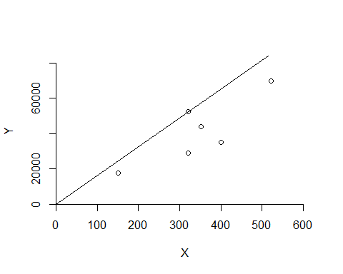

***DRS Plot***

dea.plot(x,y,RTS="vrs")

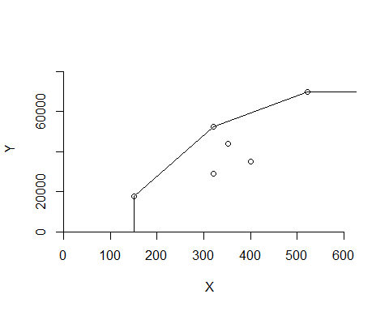

***IRS Plot***

dea.plot(x,y,RTS="irs")

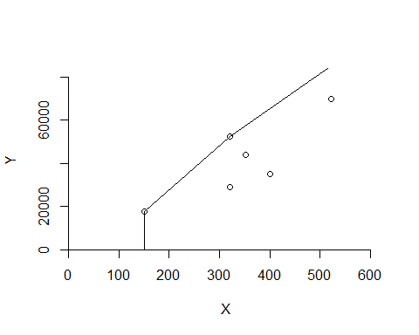

***VRS Plot***

dea.plot(x,y,RTS="vrs")



#tinytex::install_tinytex()

***FDH Plot***

dea.plot(x,y,RTS="fdh")

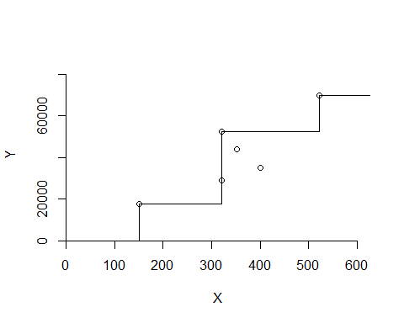

***FRH Plot***

dea.plot(x,y,RTS="add")

